Project Community
Software Design Document

CSE308
Justin Dale
Ed Linero
Eddie O'Hagan
Candy Wong

- Introduction
This document is a Software Design Description for the game Project Community.
  - Purpose
This document is intended to provided a detailed description of the technical components of Project Community. Here the focus will be on the generic game code and less on game specific content. All external and internal interfaces will be described through the use of UML class and sequence diagrams. All software choices and decisions will have at minimum, a brief justification.

  - Scope
Project Community will be a standalone game aimed at the Windows platform. In the process of developing this game a game engine will need to be built. This will be a a simple engine that will do little more than is needed for this particular game. The technical requirements for this engine will be drawn from the SRS and the game design documents.

  - Definitions, acronyms, and abbreviations
- UN Development Goals – Eight goals the UN would like to achieve by 2015 to make the world a better place, feed the starving etc.
- Imagine Cup – Microsoft student competition.
- Project Community – A game in which the players try to help accomplish the UN's goals.
- Eminent Sage Productions – The group responsible for developing Project Community.
- XNA – C# Based framework from Microsoft for game creation.
- XACT – XNA Sound tool.
- Box2D – Physics simulation and collision detection library.
- Navigation Mesh (Nav Mesh) – A collection of polygons that represent the walkable area of the map.
- Entity – A thing in a game, both tangible and intangible.
- Sprite – Visual Representation of an entity.
- GUI (pronounced gooey) – Graphical User Interface, This can refer to the players interface or the system of menus.

  - References
  - Overview
This document aims to provide an analysis of the technical requirements that were broadly outlined in the SRS and Game Design documents. Sections two and three describe the internal and external organization and interfaces at the package and class level respectively. Along with the class descriptions in section 3 there will be UML Class Diagrams. Section four will cover method-Level interactions including sequence diagrams. Section five will include any material pertaining to file formats and other deployment information.

- Package-Level Design Viewpoint

  - Project Community

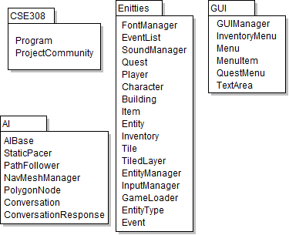
  - XNA API Usage
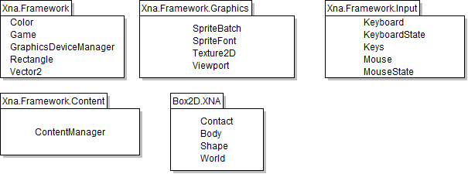
  - XNA API Usage Descriptions
    - Xna.Framework
Color | Representation of a RGBA color.
Game | Game class overriden by ProjectCommuntiy
GraphicsDeviceManager | Provides access to windows and graphics settings such as fullscreen and depth buffering.
Rectangle | Used for defining and drawing rectangles
Vector2 | Used for storing anything with (x,y) float values.

    - Xna.Framework.Graphics
SpriteBatch | Manages sprite drawing. (No sending things to the graphics card)
SpriteFont | Hold all the information describing an in game font. We will maintain a dictionary of these.
Texture2D | Two dimensional texture for drawing to the screen. All graphics will use Texture2D
Viewport | Manages the offset of the viewport due to player movement.

    - Xna.Framework.Input
Keyboard | Keyboard device.
Keys | Enumeration of keys. (Keys.Space)
KeyboardState | Gets the current state of the keyboard. Used for checking for keyboard input.
Mouse | Mouse device
MouseState | Gets the current state of the mouse. Used for checking for mouse input.

    - Xna.Framework.Content
ContentManager | Allows access to things compiled in the content pipeline.

    - Box2D.XNA
Body | A physical body. It has position, friction, shape, etc.
Contact | Represents a collision and has references to both colliding objects.
Shape | Represents the shape of an object, can be a circle or vertex defined polygon.
World | Represents of physical world, simulates the physics of the bodies in that world.

- Class-Level Design Viewpoint
  - Game/GameWorld
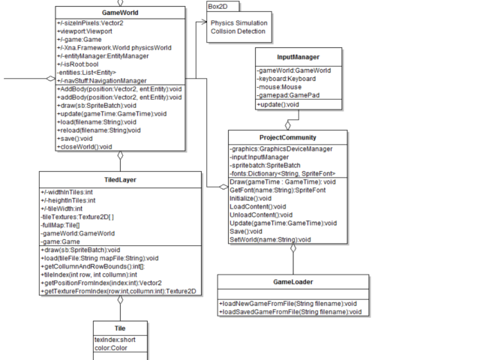
  - AI

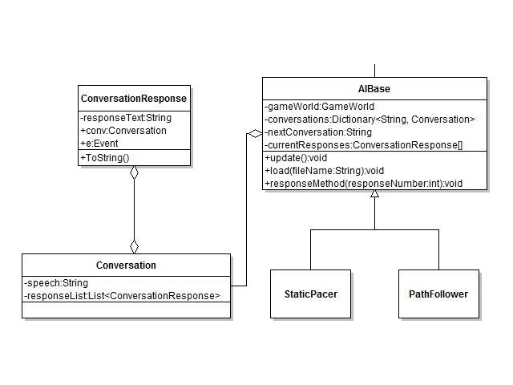
  - Navigation

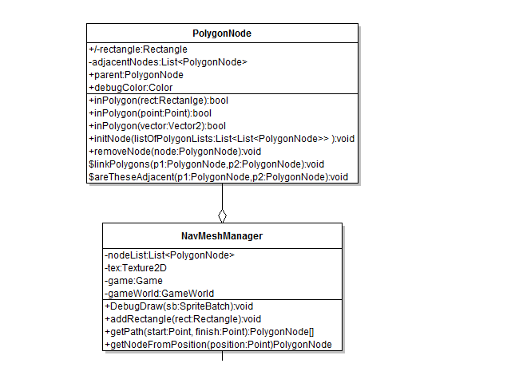
  - Enities/EntityType

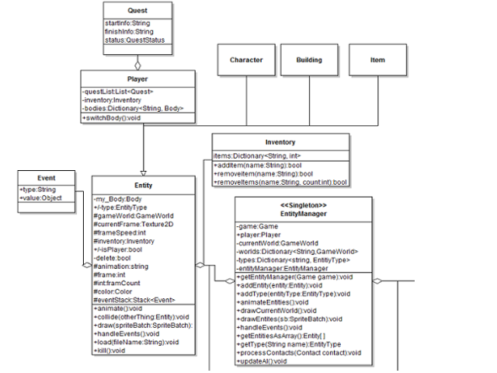
  - Menu/GUI
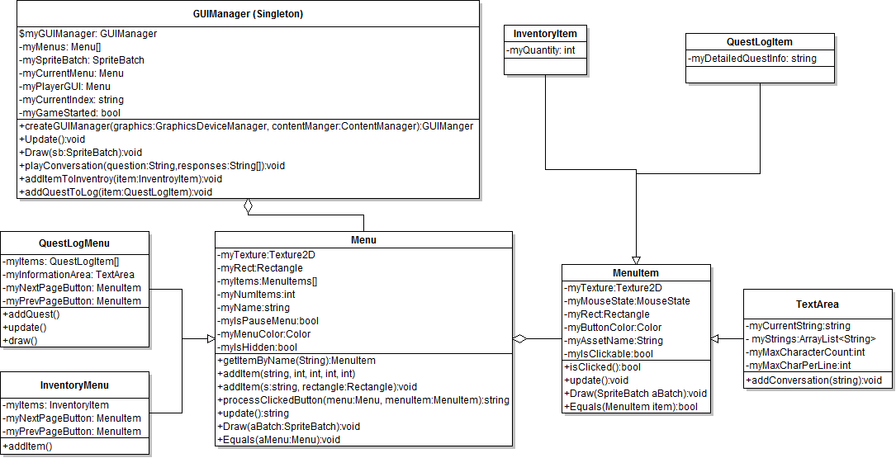

  - Misc
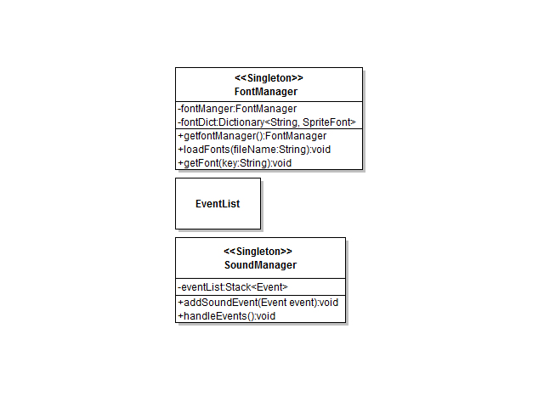

- Method-Level Design Viewpoint
  - Main Game Sequence. The diagram below shows the update and cycle of the main game loop.
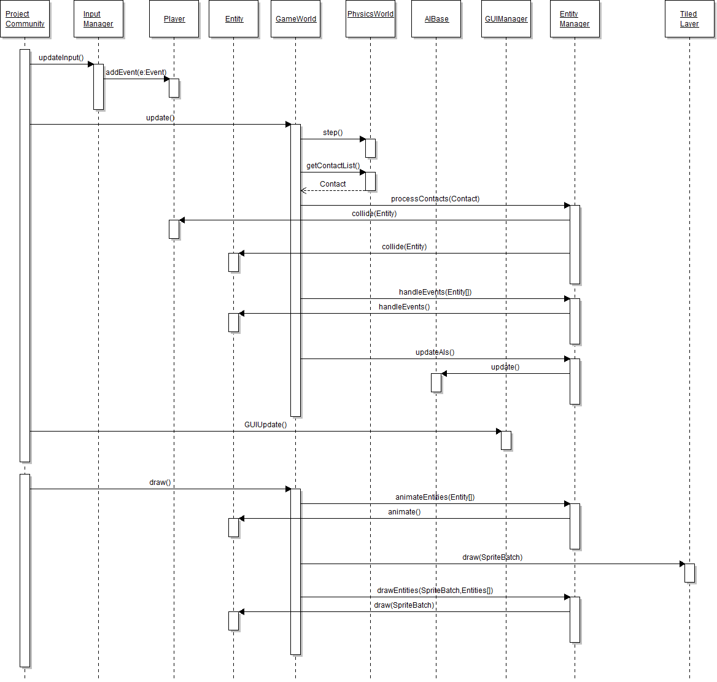
  - Game Loading Sequence. Representation of the loading process.
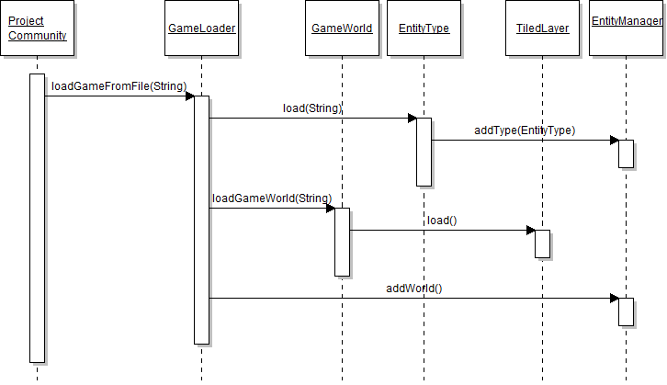
  - Play Game
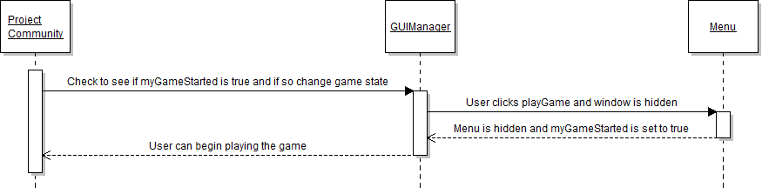

  - Exit Game
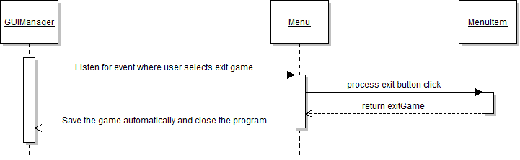
  - About Menu
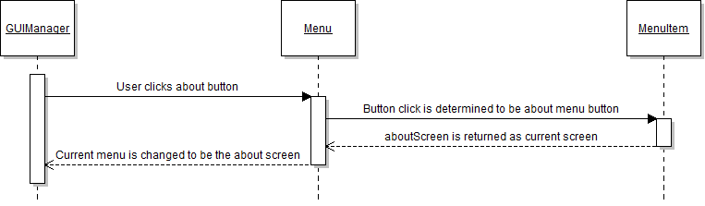
  - Controls Menu
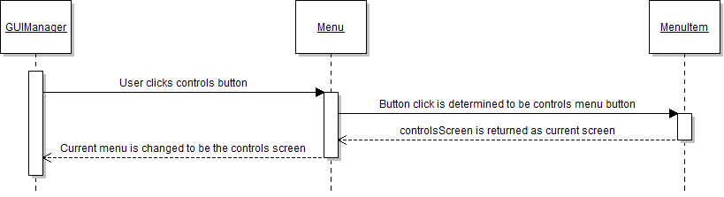
  - Load Game
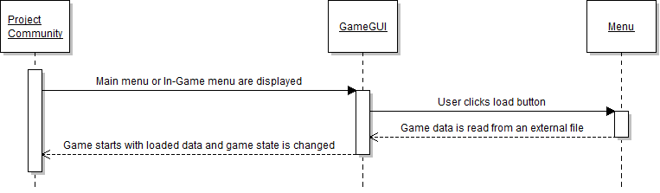
  - Pause Menu
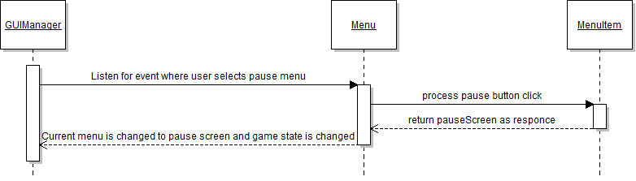
  - Play Conversation
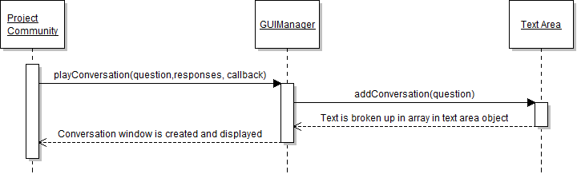
  - Save Game
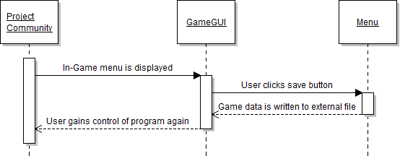
  - Show Inventory
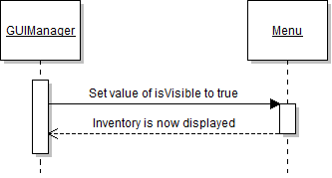

  - Show Quest Log
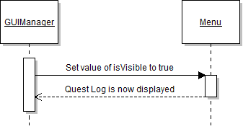
- File Structure and Formats
  - Game File
    - <Name>
      - Name of the Game.
    - <WorldData>
      - <GameWindow>
        - Defines the game window specs.
        - fullScreen - bool
        - width
        - height
      - <Gravity>
        - Gravity vector (comma separated)
    - <FontFile>
      - Pointer to font file.
    - <EntityTypes>
      - List of EntityTypes
    - <EntityType>
      - Points to an entity type file.
      - <EntityType name="Ball">XML\TestBall.xml</EntityType>
    - <Worlds>
      - List of game worlds.
    - <Subworld>
      - Points to game world file.
      - name – name of world (key).
      - Width – width of world in tiles
      - height – height of world in tiles
      - <SubWorld name="Main" width="32" height="32">GameWorld.xml</SubWorld>
  - Game World File
    - <TileFile>
      - Pointer to tile file.
    - <MapFile>
      - Pointer to map file.
      - width - width in tiles
      - height
      - <MapFile width="32" height="32">maze</MapFile>
    - <Entities>
      - List of each entity in the game world.
    - <Entity>
      - type – EntityType
      - locationX -x location in meters
      - locationY
      - <Entity type ="Building" locationX ="25.6" locationY="28" />
  - Map File – CSV in which the map is represented by a list of numbers on line one and and the dimensions on line 2.
  - Font File – List of fonts.
    - <FontList>
      - Root node of list.
    - <Font>
      - Points to a font file.
      - name – in game name of font.
      - <Font name="Default">spriteFontFile</Font>
  - Entity Type File
    - <EntityType>
      - Root of document.
    - <Data>
      - General data in attributes.
      - Restition
      - Density
      - Friction
      - <Data Restitution=".99" Density=".1" Friction="0"/>
    - <Images>
      - List of images
    - <Image>
      - <Image width="25" height="25">ball</Image>
    - <States>
      - List of states
    - <State>
      - A state definition with name and animation sequence.
      - <State name="Ball">0</State>
    - <Shape>
      - Shape of this type's body.
      - <Shape ShapeType="Circle" type="Dynamic">.172</Shape>
  - AI File
    - <Conversations>
      - Root, list of conversations.
    - <ConversationFile>
      - Points to an individual conversation file to be loaded into the AI.
      - name – Name of the conversation.
      - <ConversationFile name="ColorConvo">Example.xml</ConversationFile>
  - Conversation File
    - <Conversation>
      - Conversation root, value is the question to be asked.
      - <Conversation value="Hi, Would You Like To Change Your Color?">
    - <Responses>
      - List of potential responses to parent conversation.
    - <Response>
      - type – either “Event” or “Convo” depending on whether it triggers an event or continues the conversation.
      - value – Response string
      - <Response type="Convo" value="Yes">
    - <Event>
      - Represents the leaf of a conversation tree.
      - eventName – name of the event.
      - eventValue – string value of event.
      - <Event eventName="Set_Player_Color" eventValue="Blue"/>
  - Tile File
    - <TileList>
      - This is the root node.
    - <Tile>
      - This is a single tile image.
      - <Tile>Black</Tile>

Table of Contents

1. Introduction 2
  - Purpose 2
  - Scope 2
  - Definitions, acronyms, and abbreviations 2
  - References 2
  - Overview 2
- Package-Level Design Viewpoint 3
  - ProjectCommunity 3
  - XNA API Usage 3
  - XNA API Usage Descriptions 3
- Class-Level Design Viewpoint 5
- Method-Level Design Viewpoint 11
- File Structure and Formats 15

